Answer 10
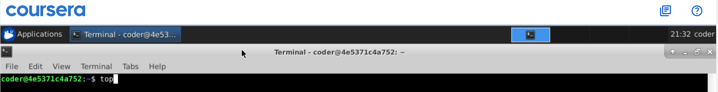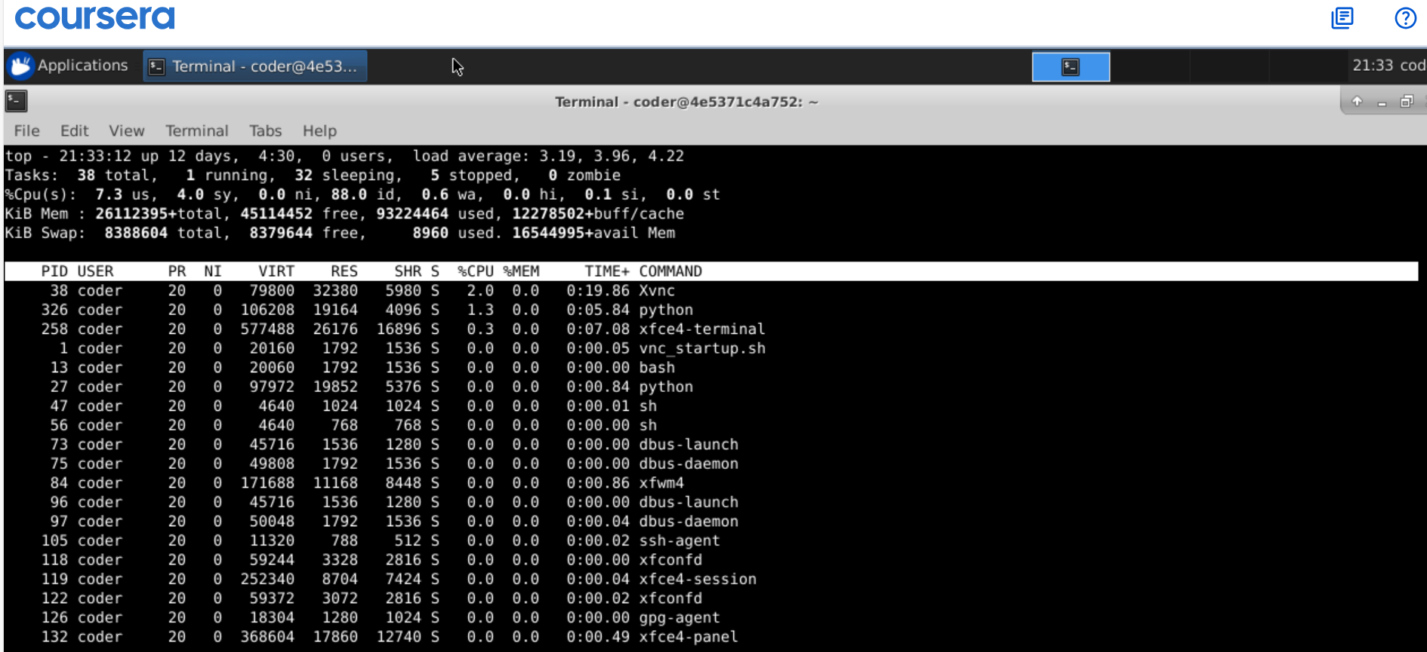
Explanation: So, there are 2 ways to do this one way is to use top command which show the up time at the top line and also show real time current CPU memory usage and all. Secondly, we can use uptime command to get desired result.
Here in the output system is up from 12 days. With 0 users and load of 3.19 in 1 minute depends on the number of cores we have in the system.

